34.16: a) 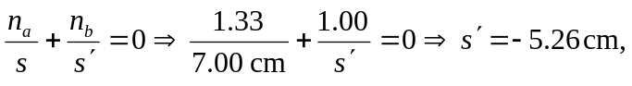so the fish appears below the surface.
b) 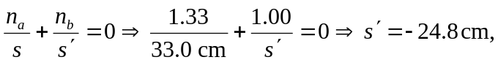so the image of the fish appears 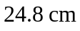below the surface.

